PROJECT REPORT

OF
INDUSTRY ORIENTED HANDS-ON EXPERIENCE (IOHE) ON

Digital Personality Twins for Adaptive Software Systems

submitted in partial fulfilment of the requirements for the award of degree of

BACHELOR OF ENGINEERING
In

COMPUTER SCIENCE AND ENGINEERING

Submitted by: | Supervised By:
Pratibha 2210992079  Mansi Garg 2210991892  Lovisha Goyal 2210991859  Samridhi Sharma  2210992244 | Dr. Preeti Saini  Associate Professor  Chitkara University Institute of Engineering and technology

DEPARTMENT OF COMPUTER SCIENCE AND ENGINEERING CHITKARA UNIVERSITY INSTITUTE OF ENGINEERING AND TECHNOLOGY
CHITKARA UNIVERSITY, PUNJAB, INDIA

DECLARATION
We hereby certify that the work which is being presented in the project report entitled "Digital Personality Twins for Adaptive Software Systems" in partial fulfilment of requirement for the award of the degree of Bachelor of Engineering (Computer Science and Engineering) submitted in the department of Computer Science and Engineering at Chitkara University Institute of Engineering and Technology, Chitkara University, Punjab, India, is an authentic record of our own work carried out under the supervision of Dr. Preeti Saini. The matter presented in this project report has not been submitted in any other university/institute for the award of any degree.

Place: Rajpura Date: ....................... | Pratibha (2210992079)  Mansi Garg (2210991892)  Lovisha Goyal (2210991859)  Samridhi Sharma (2210992244)

This is to certify that the above statement made by the candidates is correct to the best of my knowledge and belief.

Dr. Preeti Saini
Associate Professor
Department of Computer Science and Engineering
Chitkara University Institute of Engineering and Technology, Chitkara University, Punjab, India

ACKNOWLEDGEMENT

We would like to express our sincere gratitude to all those who have contributed to the successful completion of this project report on "Digital Personality Twins for Adaptive Software Systems".
We are deeply thankful to our mentor Dr. Preeti Saini, Associate Professor, for their invaluable guidance, constant encouragement, and constructive feedback throughout the course of this project. Their expertise and insights have been instrumental in shaping the direction and quality of this work.
We extend our heartfelt thanks to the Department of Computer Science and Engineering, Chitkara University Institute of Engineering and Technology, Chitkara University, Punjab, for providing us with the necessary resources and a conducive environment to carry out this research.
We are also grateful to our peers and colleagues for their support, discussions, and motivation during the development of this project.
Finally, we would like to acknowledge the researchers and authors whose published works and datasets have provided a strong foundation for our study. The Kaggle "Predict Online Course Engagement Dataset" used in our experiments is gratefully acknowledged.

Pratibha Mansi Garg Lovisha Goyal Samridhi Sharma

CONTENTS

S.No. | Title | Page No.
1 | Declaration | 2
2 | Acknowledgement | 3
3 | List of Figures and Tables | 5
4 | Abstract | 6
5 | Introduction | 7-8
6 | Methodology | 9-11
7 | Tools and Technologies | 12
8 | Implementation | 13-15
9 | Major Findings / Outcomes / Results | 16-18
10 | Conclusion and Future Scope | 19-20
11 | References | 21-22
12 | Appendices | 23

LIST OF FIGURES AND TABLES

List of Figures

Figure No. | Caption | Page No.
Fig. 1 | Architecture of Proposed Decision Personality Twin System | 13
Fig. 2 | Working Flowchart of the DPT System | 14
Fig. 3 | Comparison of Task Completion Time | 17
Fig. 4 | Comparison of Number of Clicks | 17
Fig. 5 | User Satisfaction over Iterations | 17

List of Tables

Table No. | Caption | Page No.
Table 1 | Comparison Between Existing Approaches | 10
Table 2 | Feature Mapping from Dataset to DSV | 12
Table 3 | System Parameters | 15

ABSTRACT

The existing personalization systems are primarily focused on the simple modeling of preferences of the users and not the process of actual decision making that the users are going through. However, there exist deep divergences between people concerning their choices, information processing and reaction toward uncertainty. The current paper proposes an alternative model of Decision Personality Twins (DPT) that is the computational model of user decision-making patterns.
The proposed system captures the interaction-level behavioral traits of decision time, frequency of comparison, scroll depth and reselection behavior to create a Decision Signature Vector (DSV). K-Means clustering and the Random Forest classification are machine learning tools utilized to identify and forecast all the varieties of decision personality — fast, analytical, risk-averse, and exploratory user.
A dynamically varying engine, based on the personality derived, will dynamically adjust the system behavior based on the modification of ranking strategies and interface complexity. The prototype web-based system is tested in order to prove that this model helps to save time spent on tasks, reduce the mental load, and result in a higher level of user satisfaction as compared to the traditional non-adaptive systems.
The results describe the applicability of the inclusion of behavioral decision modeling in the adaptive systems design. This study is important because it introduces an additional dimension of behavioral intelligence that cuts across artificial intelligence, human-computer interaction, and cognitive modeling, enabling the development of more adaptive and psychologically sensitive software systems.

Keywords: Decision Personality Modeling, Adaptive Systems, Behavioural AI, Human-Computer Interaction, Machine Learning, Real-Time Personalization.

INTRODUCTION
Personalization is the new entry level of the contemporary software systems, such as search engines, e-learning systems, and recommendation systems. The majority of the current methods of personalization are aimed at modelling the user preferences based on the past clicks, ratings and browsing history. These strategies enhance relevance though they do not address an important part of user behaviour — how people make choices.
Human decision-making is complex and varies greatly among individuals. There are users who are quick in making their decisions and do not take time to explore, and those who do analyze the options before deciding on an outcome. These behavioral variations affect the interaction mode of systems, process information, and uncertainty responses of the users. These patterns of cognition and behavior are commonly ignored, resulting in inefficient user experiences, decision fatigue, and diminished satisfaction.
Although there has been progress in the field of artificial intelligence and adaptive systems, the current body of research does not pay significant attention to the issue of modelling the behaviour of decision-making on a cognitive level. The existing systems curate content depending on user preferences but not their decision-making processes. This is a significant research gap in creating truly smart and user-friendly systems.
In an attempt to overcome this weakness, this paper proposes the Decision Personality Twin (DPT) as a computational framework that explains the decision-making behavior of the user depending on interaction patterns. The suggested system records minute aspects of behavior, including the time of decision, the depth of scrolls, frequency of comparison, and reselection behavior to form a Decision Signature Vector (DSV). With machine learning, users are classified into different types of decision personalities, and in the process, the system is able to dynamically change its behavior.

Objectives
The primary aim of this work is to develop and deploy an adaptive software system which utilises decision personality modeling to improve user interaction. In contrast to traditional systems, the proposed solution alters the presentation and logic of the system based on the deduced user behavior, allowing individual ranking, reduced cognitive load, and increased efficiency in information retrieval tasks.
The key contributions of this paper are as follows:
    - Presentation of a new Decision Personality Twin model of user decision behaviour.
    - Training a behavioral feature extraction process to develop Decision Signature Vectors (DSV).
    - Combination of machine learning applications in personality classification and prediction.
    - Development of a real-time adaptive system which dynamically alters search results based on user decisions.
    - Experimental confirmation of increased task efficiency and user satisfaction.

Scope of the Study
The bridge created by this work covers the gap between artificial intelligence, human-computer interaction, and cognitive modeling, leading to the design of more intelligent and psychologically conscious adaptive systems. The scope of this project includes the design, implementation, and evaluation of the DPT framework using simulated behavioral datasets within an online search context.

METHODOLOGY

Literature Review
Artificial intelligence and human-computer interaction have been widely subjected to the study of personalization systems. The current recommender systems are based on collaborative filtering and matrix factorization algorithms to forecast user preferences according to past interactions . Content-based recommendation methods also use item attributes and user profiles to create personal recommendations . These methods are, however, more concerned with what users want and not the decision-making process.
Recent studies have highlighted the need to include user behavior in personalization systems. Clickstream analysis and web usage mining techniques are used to analyze user navigation patterns and sequences of interaction . These techniques get inferences out of metrics like clicks, dwell time, and browsing paths. Although effective, they primarily measure observable behaviour and not the underlying thought process.
Proposals have also been put forward towards adaptive user interface systems that dynamically adjust the presentation and layout of content . Machine learning has been incorporated to customize interfaces based on user interactions. Nevertheless, many systems are not dynamically adaptable in real time due to the use of fixed user models or rule sets.
Clustering algorithms like K-Means and classification models like Random Forests have enhanced personalization significantly. According to recent research (2020-2025), behavioral and cognitive modeling is becoming increasingly significant in personalization systems. Interaction-level descriptors like decision time, scrolling behavior, and exploration patterns can provide further insight into user intent . Reinforcement learning strategies have also been suggested for dynamic adaptation to ongoing user interaction .
Cognitively, users have varying decision-making styles, including impulsive, analytical, risk-averse, and exploratory . These behavioral characteristics are hardly incorporated in adaptive software systems despite their importance.

Table 1: Comparison Between Existing Approaches

Ref. No. | Method | Focus Area | Techniques Used | Limitations
[1] | Collaborative Filtering | User Preference | Matrix Factorization | Ignores decision behavior
[2] | Content-Based Filtering | Item similarity | Feature-based ML | Limited adaptability
[3] | Clickstream Analysis | User interaction logs | Sequence analysis | Focus on actions only
[4] | Web Usage Mining | Navigation behavior | Data mining | No cognitive modeling
[5] | Adaptive UI Systems | Interface personalization | ML / rule-based | Static adaptation
[6] | Clustering Models | User segmentation | K-Means | No decision modeling
[7] | Classification Models | Prediction | Random Forest | Outcome-focused
[8] | Behavior Modeling | Interaction patterns | ML models | Limited decision insight
[9] | RL-based Systems | Dynamic adaptation | Reinforcement learning | Complex implementation

Proposed Work — DPT Framework
This section presents the proposed DPT framework for adaptive search systems. The system simulates the decision-making behaviour of users and dynamically alters search results according to assumed personality characteristics.
The proposed system includes 4 significant elements:
    - User Interaction Module: Records user behavior including search queries, clicks, scrolling, and decision time.
    - Behavior Logging Module: Captures decision time, number of links explored, scroll depth, click position, and reselection behavior.
    - Decision Personality Modeling Module: Models the collected data to create a DSV that reflects user behavior patterns.
    - Adaptive Search Engine: Ranks and personalizes search results based on the forecasted personality type .

Decision Signature Vector (DSV)
A feature vector known as the Decision Signature Vector (DSV) is used in order to model user behavior, defined as:
DSV = [T_d, N_l, S_d, C_p]

Where:
    - T_d = Decision Time
    - N_l = Number of Links Explored
    - S_d = Scroll Depth
    - C_p = Click Position

Personality Classification using K-Means
The system relies on K-Means clustering to classify users into decision personality types. The objective function minimized is:
J = Σk Σ(xi∈Ck) ||xi - μk||²

Where:
    - xi = user behavior vector
    - Ck = kth cluster
    - μk = cluster centroid
The resulting clusters represent Fast Decision Makers, Analytical Users, Exploratory Users, and Risk-Averse Users.

Adaptive Ranking Strategy
According to projected personality, the system adapts as follows:
    - Fast Users: Show top results immediately.
    - Analytical Users: Show detailed and comparison-based results.
    - Exploratory Users: Show diverse options.
    - Risk-Averse Users: Show highly rated and safe results.
Adaptive ranking is accomplished using machine learning techniques that constantly advance system performance according to user feedback .

TOOLS AND TECHNOLOGIES
The proposed system is deployed using a combination of modern web technologies and machine learning frameworks. Table 2 provides a summary of the tools and technologies used across different layers of the system.

Frontend
The front end is created with React.js in order to offer an interactive and responsive user interface. React.js enables dynamic rendering of search results and real-time feedback based on personality adaptation.

Backend
Making use of Node.js and Express, the backend is constructed to process API requests and handle the core logic of the system. The backend interacts with the ML model by making REST API calls to predict the personality of the user in real-time.

Database
MongoDB is used as the database to store logs of user interactions. Its flexible schema allows efficient storage of behavioral data including decision time, scroll depth, click positions, and exploration patterns.

Machine Learning
Python is employed for all machine learning components, with Scikit-learn used as the primary library for K-Means clustering and model training. Flask is employed in the development of a lightweight REST API that allows communication between the backend and the ML model.

Table 2: Feature Mapping from Dataset to DSV

Feature | Dataset Column | Used As
Decision Time | TimeSpentOnCourse | Time taken to decide
Links Explored | NumberOfVideosWatched | Exploration behavior
Scroll Depth | CompletionRate | Depth of interaction
Click Behavior | CourseCompletion | Selection pattern

IMPLEMENTATION

System Architecture
The overall architecture of the proposed system follows a client-server model where the frontend submits user queries to the backend. The backend captures user interaction data and interacts with the ML model via REST API requests [17]. The ML model calculates behavioral features and predicts the personality type of the user in real time. According to this forecast, the backend alters the ranking of search results and sends personalized responses to the frontend.
Fig. 1: Architecture of Proposed Decision Personality Twin System
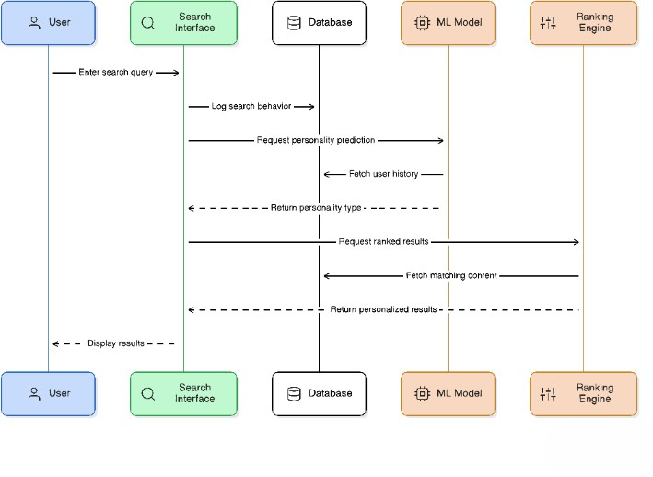

Working Flow
The system adheres to an organized workflow beginning with user query input up to the adaptive generation of results. The user first types a search query and interacts with the results shown. The system constantly records behavioral information like clicks, scrolling behavior, and decision-making time.

This information is processed to form a DSV, upon which the machine learning model predicts the type of decision personality of the user. According to the expected personality, the adaptive ranking engine alters the ranking and display of search results. A feedback loop is also provided to continuously improve the model by reusing new interaction data, enhancing personalization accuracy over time.
Fig. 2: Flowchart of Working Flow
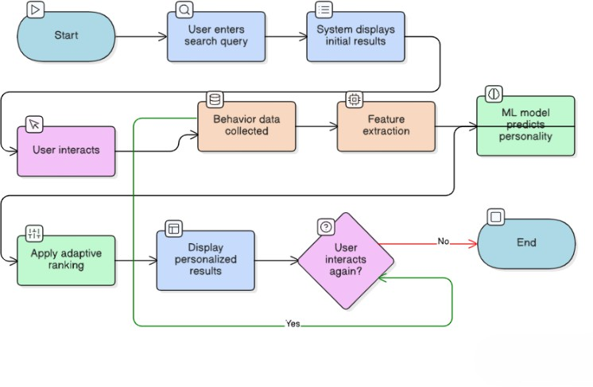

Dataset Description
The model is trained using the Predict Online Course Engagement Dataset from Kaggle , consisting of 2,000 records of simulated user interactions. The data is synthetically generated and indicates behavior patterns within an online learning setup. It has 7 features, with 4 being mapped to the DSV as shown in Table 2.
As there are no real-time behavioral datasets available, feature mapping is done to emulate decision-making patterns needed to create the Decision Signature Vector.

System Parameters

Table 3: System Parameters

Parameter | Value
Clustering Algorithm | K-Means
Number of Clusters (K) | 3
Attributes Used | Decision Time, Links Explored, Scroll Depth, Click Position
Backend Server Port | 5000
Frontend Port | 3000
ML API Port | 5001

MAJOR FINDINGS / OUTCOMES / RESULTS

Personality Classification Results
The K-Means clustering algorithm successfully grouped users into specific types of decision personality depending on their interaction patterns. The clustered groups identified are:
    - Fast Decision Makers — Users who decide quickly with minimal exploration.
    - Analytical Users — Users who explore extensively and compare options before deciding.
    - Exploratory Users — Users who browse broadly across diverse options.
Each cluster represents a distinct decision-making behavior, differentiated by decision time, number of interactions, and depth of exploration.

Performance Analysis
The adaptive search system was compared with a non-adaptive baseline system in terms of the following performance measures:
    - Task Completion Time — Time taken by users to find and select relevant results.
    - Number of Clicks — Total interactions required before reaching a decision.
    - User Interaction Depth — Depth of exploration within search results.
The adaptive system proved to be more efficient, with reduced unnecessary interactions and more relevant results tailored according to user personality. Fast users benefited from immediate top-ranked results, while analytical users received detailed comparison-oriented outputs.

Result Visualization
Fig. 3: Comparison of Task Completion Time
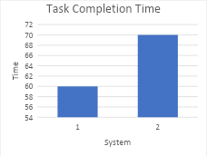
The adaptive system reduces task completion time significantly compared to the non-adaptive baseline system across all user personality types.
Fig. 4: Comparison of Number of Clicks
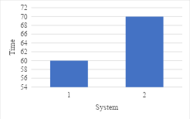
The number of clicks required to reach a decision is significantly reduced in the adaptive system, indicating improved search efficiency and reduced cognitive load.
Fig. 5: User Satisfaction over Iterations
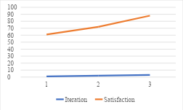
User satisfaction increases progressively over time due to the continuous learning feedback loop, demonstrating the system's ability to improve personalization accuracy through repeated interactions.

Discussion
The experimental outcomes show that the inclusion of decision personality modeling leads to a significant enhancement of system performance. The feedback loop also increases the flexibility of the system as it learns from user interactions. The proposed system eliminates cognitive load and enhances user satisfaction in comparison with conventional systems .
Nevertheless, the system is based on simulated datasets which may not necessarily reflect actual user behavior in all contexts. Future development can be aimed at gathering real-time user interaction data to enhance the accuracy of the models .

CONCLUSION AND FUTURE SCOPE

Conclusion
This paper proposes a new adaptive search system known as Decision Personality Twin (DPT) to conceptualize and use the behavior of users in making decisions to achieve better personalization. In comparison to the traditional systems that only pay attention to the preferences of users, the proposed approach records the trends of behavior patterns — decision time, exploration depth, and the frequency of interaction — in order to comprehend the decision-making process of users.
The system uses K-Means clustering to group users into various types of decision personality: fast, analytical, and exploratory users. According to the forecasted personality, the adaptive ranking mechanism dynamically adjusts search results to suit individual user behavior in a better way.
The experimental findings show that the recommended system enhances performance by shortening the time spent on completing tasks, decreasing the number of user interactions, and increasing overall user satisfaction. The use of a feedback loop brings on board the ability of continuous learning and improvement of the system over time.
Altogether, the presented framework implements an additional behavioural intelligence layer in adaptive systems that fills the gap between artificial intelligence and the process of human decision-making.

Future Scope
Nonetheless, the existing application is based on artificial data, which might not be a complete representation of real user behavior. Avoiding all limitations of the current work, future directions include:
    - Gathering real-time interaction data from actual users to improve model accuracy and generalizability.
    - Incorporating advanced models such as deep learning or reinforcement learning for more nuanced personality prediction.
    - Extrapolating the system to real-world applications including e-learning platforms, healthcare decision support systems, and intelligent assistants.

    - Exploring privacy-preserving techniques to ensure ethical handling of behavioral data.
    - Extending the DSV to include additional behavioral features such as mouse movement patterns and eye-tracking data.

REFERENCES
- H.-J. Xue, X.-Y. Dai, J. Zhang, S. Huang, and J. Chen, "Deep Matrix Factorization Models for Recommender Systems," 2017.
- M. De Gemmis, P. Lops, C. Musto, F. Narducci, and G. Semeraro, "Semantics-Aware Content-Based Recommender Systems," Recommender Systems Handbook, Second Edition, pp. 119-159, 2015.
- J. Mao, C. Luo, M. Zhang, and S. Ma, "Constructing click models for mobile search," 41st International ACM SIGIR Conference, pp. 775-784, Jun. 2018.
- J. Kaur and J. S. Bal, "Machine Learning Approach to Recommender System for Web Mining," Lecture Notes on Data Engineering and Communications Technologies, vol. 38, pp. 638-646, 2020.
- S. V. Kolekar, R. M. Pai, and M. M. Manohara Pai, "Rule based adaptive user interface for adaptive E-learning system," Educ. Inf. Technol., vol. 24, no. 1, pp. 613-641, Jan. 2019.
- R. Xu and D. Wunsch, "Survey of clustering algorithms," IEEE Trans. Neural Netw., vol. 16, no. 3, pp. 645-678, May 2005.
- G. Louppe, L. Wehenkel, A. Sutera, and P. Geurts, "Understanding variable importances in forests of randomized trees," Adv. Neural Inf. Process. Syst., vol. 26, 2013.
- M. Shakeri et al., "User behavior modeling for AR personalized recommendations in spatial transitions," Virtual Reality, vol. 27, no. 4, pp. 3033-3050, Dec. 2023.
- C. A. Martins, C. F. Dorneles, and M. A. Winckler, "A Comprehensive Review of User Interaction for Recommendation Systems," iSys Journal of Information Systems, vol. 17, no. 1, Dec. 2024.
- "Predict Online Course Engagement Dataset," Kaggle. [Online]. Available: https://www.kaggle.com/datasets/rabieelkharoua/predict-online-course-engagement-dataset. Accessed: Mar. 25, 2026.
- B. Alsoufi, "Thinking, fast and slow," Journal of Thoracic and Cardiovascular Surgery, vol. 153, no. 3, pp. 646-647, Mar. 2017.
- S. Zhang, L. Yao, A. Sun, and Y. Tay, "Deep Learning Based Recommender System," ACM Computing Surveys, vol. 52, no. 1, Feb. 2019.
- X. He, L. Liao, H. Zhang, L. Nie, X. Hu, and T. S. Chua, "Neural collaborative filtering," 26th International World Wide Web Conference, pp. 173-182, 2017.
- G. Adomavicius et al., "Context-Aware Recommender Systems: From Foundations to Recent Developments," Recommender Systems Handbook: Third Edition, pp. 211-250, 2022.

- H. Van et al., "Deep Reinforcement Learning and the Deadly Triad," Dec. 2018. [Online].
Available: https://arxiv.org/abs/1812.02648v1
- F. Cena, S. Likavec, and A. Rapp, "Real World User Model: Evolution of User Modeling Triggered by Advances in Wearable and Ubiquitous Computing," Information Systems Frontiers, vol. 21, no. 5, pp. 1085-1110, 2018.
- A. G. Martin et al., "A survey for user behavior analysis based on machine learning techniques," Applied Intelligence, vol. 51, no. 8, pp. 6029-6055, Aug. 2021.
- A. Adadi and M. Berrada, "Peeking Inside the Black-Box: A Survey on Explainable Artificial Intelligence (XAI)," IEEE Access, vol. 6, pp. 52138-52160, Sep. 2018.
- B. Shneiderman, "Bridging the Gap Between Ethics and Practice," ACM Transactions on Interactive Intelligent Systems, vol. 10, no. 4, Oct. 2020.
- P. Brusilovsky et al., "Interfaces and Human Decision Making for Recommender Systems," RecSys 2020, pp. 613-618, Sep. 2020.
- C. Troussas, A. Krouska, and C. Sgouropoulou, "Human-Computer Interaction in Education,"
pp. 1-38, 2025.
- T. Schurmann and P. Beckerle, "Personalizing Human-Agent Interaction Through Cognitive Models," Frontiers in Psychology, vol. 11, p. 561510, Sep. 2020.

APPENDICES

Appendix A: Team Details

Roll No. | Name | Email
2210992079 | Pratibha | pratibha2079.be22@chitkara.edu.in
2210991892 | Mansi Garg | mansi1892.be22@chitkara.edu.in
2210991859 | Lovisha Goyal | lovisha1859.be22@chitkara.edu.in
2210992244 | Samridhi Sharma | samridhi2244.be22@chitkara.edu.in

Appendix B: Technology Stack Summary

Layer | Technology | Purpose
Frontend | React.js | Interactive user interface
Backend | Node.js + Express | API processing and system logic
Database | MongoDB | User interaction log storage
ML Framework | Python + Scikit-learn | K-Means clustering and classification
ML API | Flask | REST API for ML model integration

